St. Jude School and
Knights of Columbus Paul Breen Council #8576
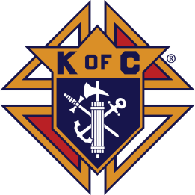
Present the 23rd Annual
ST. JUDE GOLF CLASSIC
FRIDAY, October 22, 2021
SHOT GUN START:
8:00 AM, check-in begins at 7 am
1:00 PM, check-in begins at 12 pm

COURSE: Creeks Bend Golf Club, 5900 Hixson Pike, Hixson, TN 37343

COST: $100/Player - 8 AM or 1:00 PM round; $160/Player for both rounds
For Sponsorship Information/Cost - See Attached Information

Tournament Rounds Include:• 18 Holes (cart included) • Unlimited Range Balls
• Goody Bag (1 per golfer) • Hole in One Contest • Closest to the Hole Contest • Longest Drive Contest • Putting Contest •The Looking Good – Best Dressed Team Trophy •FOREty FOREty Contest • Breakfast, Lunch, Dinner, Snacks and Beverages • 2 Flights/Round with Prizes

REGISTER NOW – Tournament Gift is only guaranteed with registrations received by October 4.
Checks may be made to: St. Jude School

COMPLETE THIS FORM AND RETURN IT WITH PAYMENT TO
ST. JUDE SCHOOL OR TO prestonk@mysjs.com:

___AM ___PM ___Both Rounds
SPONSOR:___ Eagle ___Birdie ___ Par ___Contest ___Hole

TOTAL ENCLOSED: $

Name or Company Name (If Applicable)
Primary Contact Phone #: Email Address:

1. Name

2. Name

3. Name

4. Name

I CAN’T PARTICIPATE IN THE TOURNAMENT BUT WISH TO DONATE TO THE 2021 ST. JUDE GOLF CLASSIC AND THE CLASSROOM ADOPTION PROGRAM AND KNIGHTS OF COLUMBUS SERVICE THAT IT SUPPORTS! Donation Enclosed $________
St. Jude School●930 Ashland Terrace●Chattanooga, TN 37415●Phone 423-877-6022

