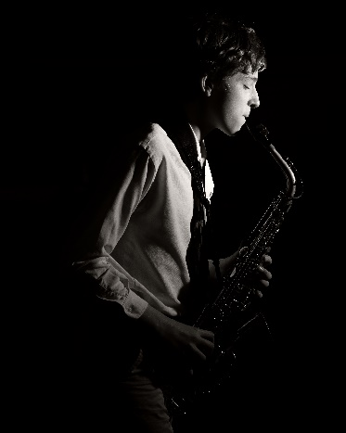
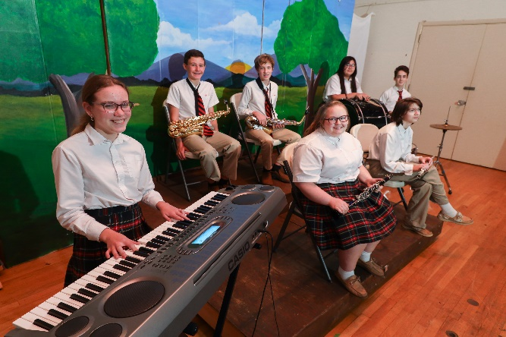

SJS & OLPH
SUMMER BAND CAMP
for Rising 5th – 8th Grade
July 11 – 15, 2022
St. Jude School, 930 Ashland Terrace, Chattanooga, TN 37415
Cost - $100/participant
Join us this summer for a week of awesome band fun!
Register based on your level of experience:
- Beginner band (1st year in band)
9:00am - 11:00am
- Advanced band (1 or more years of band experience)
11:30am - 1:30pm
To register, email Band Director Tony Tortora at mtortora054@gmail.com,
or call him at (423)-596-5219.

He will need:

1) Student name
2) Guardian name / email / phone number
3) Instrument
4) Years in Band

