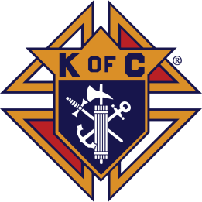

23rd Annual

ST. JUDE
GOLF CLASSIC

FRIDAY, October 22, 2021

Co-Sponsored By: St. Jude School and the Knights of Columbus
Paul Breen Council #8576

St. Jude School and Parish
930 Ashland Terrace
Chattanooga, TN 37415
(423) 877-6022

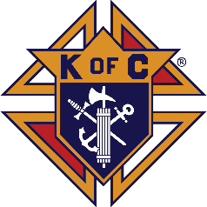

August 9, 2021

To Whom It May Concern,

We are contacting you regarding our request for your assistance in supporting the 23rd annual St. Jude Golf Classic. This event is sponsored by entities associated with St. Jude Parish in Chattanooga, TN. Proceeds will be used to benefit EVERY student via the Classroom Adoption Program and EVERY parishioner and visitor via the Knights of Columbus Service Programs.

This day will include 2 rounds of golf with related events, meals and the volunteer support of dozens. We are seeking donations to include food, beverages, and prizes. Obviously, the number of donations we receive greatly affects the proceeds we are able to direct to our cause. Your kind consideration and generosity are greatly appreciated by the families of St. Jude Parish.

For additional information, please refer to our website http://www.mysjs.com/support/golftournament.cfm, or contact one of the individuals listed below. Again, thank you for your support.

Sincerely,

Kathleen M. Preston, St. Jude School, Director of Development, prestonk@mysjs.com
Naino Leo, Council #8576, nleo909091@aol.com

Patrick & Maggie Shutters, Tournament Hosts, maggieshutters@gmail.com

SPONSORSHIP OPPORTUNITIES

EAGLE SPONSOR $2,500
- Logo/Name on Golf Shirts
- Name on Large Welcome Banner at Course Entry
- Play for 4 in the Tournament
- Recognized at Lunch – Eagle Sponsor
- Logo/Name on Program as Eagle Sponsor
- Listing as Sponsor on School Website as Eagle Sponsor

BIRDIE SPONSOR $1000
- Name on Large Welcome Banner at Course Entry
- Play for 4 in the Tournament
- Recognized at Lunch – Birdie Sponsor
- Logo/Name on Program as Birdie Sponsor
- Listing as Sponsor on School Website as Birdie Sponsor

PAR SPONSOR $500
- Play for 4 in the Tournament
- Recognized at Lunch – Par Sponsor
- Logo/Name on Program as Par Sponsor
- Listing as Sponsor on School Website as Par Sponsor

CONTEST SPONSOR $300 (LONGEST DRIVE/CLOSEST TO PIN)
- 1 Medium Sign at Contest Hole
- Recognized at Lunch – Contest Sponsor
- Logo/Name on Program as Contest Sponsor

HOLE SPONSOR $150
- 1 Sign at Sponsor Hole
- Recognized at Lunch – Hole Sponsor
- Logo/Name on Program as Hole Sponsor

WHY OUR TOURNAMENT?

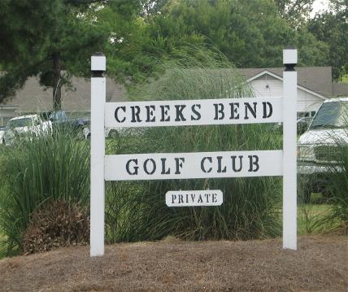

- Tournament Site – Creeks Bend Golf Club, Hixson
- Proceeds from this tournament have touched so many facets of St. Jude Parish. Just some of the areas that have benefited from the success of our tournament include:
  - The Family Life Center building fund
  - Technology and computers
  - Curriculum materials
  - Parish Life Center basement bathrooms
  - The annual Classroom Adoption Program (work that occurs every summer, manned by VOLUNTEER parents) – provides classroom painting, addition of furniture and fixtures, maintenance and repairs and in 2018 we supported and participated in the remodel of our Library/Computer Lab.

The works of our Knights of Columbus, the world's largest Catholic fraternal service organization, touch everyone in our parish and beyond into our community. The funds they raise through this event and others provide benefit in so many ways:
  - Campaign to decrease parish debt
  - Assistance with the new church carpet
  - Parish breakfasts, dinners and celebrations
  - Gifts, support and assistance to the school
  - Funding to purchase wheelchairs for those in need
  - Help with housing for special Olympics
  - Altar Server appreciation luncheon
  - Monthly dinner at the UTC Catholic Student Center
  - Coat Drives

- Please join us to sponsor, play, and volunteer; or perhaps donate. No gift is too small and it will be well used. If you can come out on October 22, we promise you’ll have fun while benefitting EVERYONE at St. Jude.

- This event is a perfect example of the strong community at St. Jude. Two of our largest ministries work together to support and assist our parish. We ask that you help us continue this good work. Make a difference. It’s what we do.

