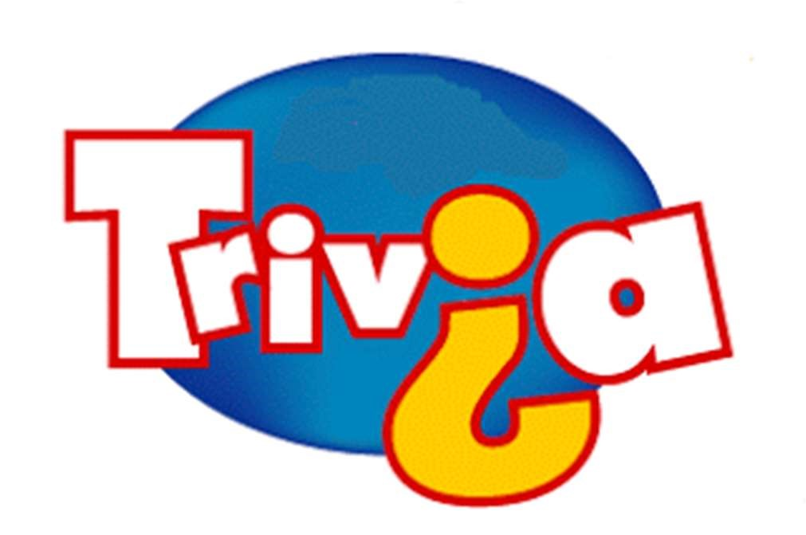
St. Jude Parish
Trivia Night

Saturday, September 25, 2021 6pm

Get your team (of up to 8) ready for an evening of
Food, Fun and Frivolous Facts!! BIG $$$ Cash money!

1st Place- $500 2nd Place- $300 3rd Place- $200

Price includes dinner/drinks/desserts and door prizes!

Sat Sept 25 6:00pm- dinner included! (come after Mass!)

*St. Jude School- Siener Hall *$150 per table up to 8/team
*All money supports St Jude Parish!

Registration due by Wed. Sept 22- Call Kyra with questions, suggestions, or to help!!!
Registration Form for St. Jude Parish Trivia Night!
Space is limited to 18 teams- register your team TODAY! (Last year we SOLD OUT!)
Name:________________________________________________
Email:________________________________________________
Phone number______________________
Food allergies?________________________________________
Team Name____________________________________________
Payment amount- $150 cash___________ check#______________

---------------------------------------------------------------------

Payment is for a table of up to 8 players. Price includes an evening of trivia, music, dinner, non-alcoholic drinks and dessert. Cash prizes for tops teams and various door prizes. Registration due by Wed, Sept 22. Reserve today with your payment as tables are limited. Make check out to St Jude Church. Forms are due to the Church office or through St Jude School, Sunday Mass collection basket, or Kyra King.
Can’t play but want to help? Volunteers needed for the evening to help serve and tabulate results. Also looking for donation items for door prizes. Please see Kyra if you can help!

