Trunk or Treat
at St. Jude Parish!

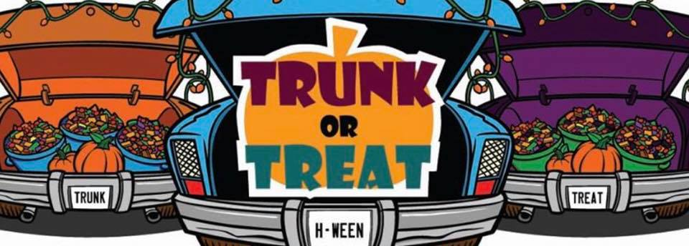

Friday, Oct. 29, 6pm-9pm
Decorate your vehicle! Music
CANDY! Game and Activity at each car!

Tailgate with your friends!
Hay Rides Costume Contest

Cookout provided by The Knights!

Prizes for Most Creative Car and Best Activity!

