TWO Summer Catholic Volleyball Sessions
Available in 2022!
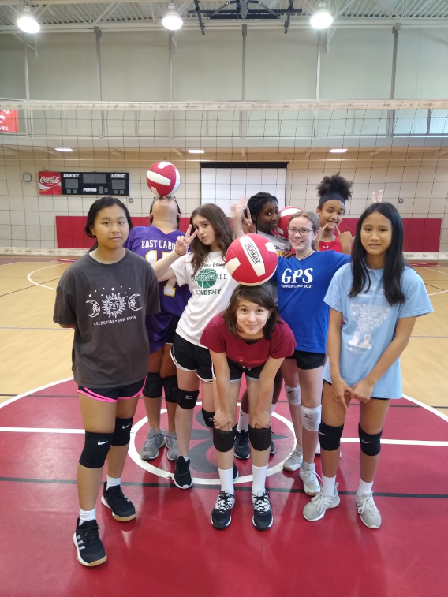
BOYS and GIRLS WELCOME!

Session 1 is 5/31-6/3/22
Session 2 is 7/18-7/21/22

DISCOUNT for attending both camps
($30 discount comes off price of second camp).
Sign up and reserve your spot today!

Catholic Volleyball Camp Session: 5/31-6/3/2022
Get an early jump on the summer! Catholic volleyball camp is open to all boys and girls wanting to learn the sport or improve their skills....and have fun! That is a must! They will learn skills such as serving, passing, hitting, setting (digging, blocking and more for more advanced campers) and we will have tons of fun activities in between!

Location: St Jude Gym, 930 Ashland Terrace, Chattanooga, TN
Date: 5/31-6/3/22 (Tuesday-Friday)
Cost: $150 per camper (payable first day at check-in by cash or check)*

Ages: Rising Grades 2-6 9am -12pm
Ages: Rising Grades 7+ 1pm- 4pm

Campers will need athletic clothing (shorts and t-shirts are popular), athletic shoes, WATER BOTTLE/DRINKS, snacks, knee pads if they have them.

Campers will have a snack time mid-session each day.

*$30 Discount on Session 2 (July 18-21/22) when camper attends both sessions.
Discount taken off session 2 payment.

Link to session 1 https://docs.google.com/forms/d/16DI5WVqQB-F1tr17mb9xKfPJ__G9GS3Hhai_7B0iIGw/edit

Link to session 2 https://docs.google.com/forms/d/1VrntbCLHdAZi1yReQd-9HzvugrJT-CWQP-wnQ-hT92Y/edit

