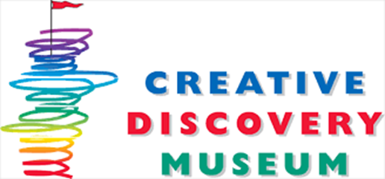
Creative Discovery Museum’s: Destination Discovery
Now offering aftercare programming at St. Jude’s Catholic School
Mission Statement:
Destination Discovery is a Reggio-Emilia inspired afterschool enrichment program, based on best practices and philosophies for learning, implemented by the Creative Discovery Museum. Destination’s goal is to show the potential in all children and inspire them to be competent, creative and resourceful learners who can discover and problem solve with ingenuity and confidence.
What is Destination Discovery?
Creative Discovery Museum’s Destination Discovery program was first established at St. Peters Episcopal School in 2013. Destination Discovery has curriculum with monthly themes, which are determined based on the “child-led, teacher framed” Reggio-Emilia approach. Past themes have included illusion and magic science, inspired by student interest in slight of hand tricks, and survival skills, which stemmed from observations of students creating natural shelters on the playground and experimenting with solar energy and magnifying glasses.
Destination Discovery is a fully at-will program and participation in planned activities is not forced. Children always have the option to free-play outside, with provided sensory materials or in centers. Destination primarily uses the Reggio approach known as ‘providing a provocation,’ which means the activities are offered at a station with loose materials, arranged and displayed in an inviting way, which inspires ingenuity and open-ended project results. Because provocations are based on student interest, the success rate for participation, learning and discovery is increased.
Provocations are also chosen with learning schemas in mind and are adapted to be age-appropriate for each group. In addition to curricular programming, Destination Discovery is committed to the social/emotional well-being of all children. Staff is specially trained to work with all behaviors and does not use time-outs or bar participation. Instead, Destination staff protocol is to work individually with children and those experiencing behavioral challenges are brought aside to discuss their situation and be coached to work through and solve their social issues, promoting self-regulation, mindfulness and kindness.
Destination Discovery’s programming and staff culture is designed to foster meaningful relationships with students, their families and faculty at your school, to work together to achieve the most enriching experience aftercare has to offer. We look forward to meeting and getting to know you and your new Discoverers!

